December 2014
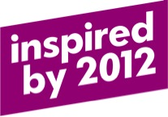

BEPE is 1!

It was this time last year that we kicked off the Built Environment Professional Education Project – the Olympic and Paralympic legacy project that aims to embed inclusive design into the education and training of built environment professionals.

Minister of State for Disabled People, Mark Harper MP, says that the project will help make a difference:

“The key built environment professional institutions have shown an enthusiasm and desire to do more in the area of inclusive design education. Introducing built environment students to the concept of an inclusive environment at the beginning of their professional education and then embedding the principles throughout their learning will help in the long term to change attitudes towards disability”

The first anniversary was marked with a reception at City Hall in London, hosted by Deputy Mayor Sir Edward Lister and attended by a vast range of stakeholders, including built environment professional institutions, educators, and local and national government. As Sir Edward said in his opening remarks:

“We have worked with a whole host of academic institutions to begin the dialogue of embedding inclusive design. Making changes to courses will be a sea-change but it will have enormous benefits, and those benefits will be long lasting……We are fully on board with this – this is what we want to achieve.”

If you’d like to hear more, the speeches from the reception are available to watch online on the GLA website.

So, as we blow out the candles on the BEPE birthday cake it seems like a good moment to take stock of what we’ve achieved so far and look ahead to the next twelve months.

Our main aim for 2014 was to gain support from the professional institutions and work with them to identify what changes could be made and by when. It was great to find that there was a real enthusiasm for the project and a desire from the professional institutions to do more in the area of inclusive design. We started off in December 2013 with supportive statements from 6 institutions, and over the course of the year we’ve secured more – we now have support from 14, with the latest additions coming from SCHOSA (the Standing Conference of Heads of Schools of Architecture), LABC (Local Authority Building Control) and the CIC (Construction Industry Council).

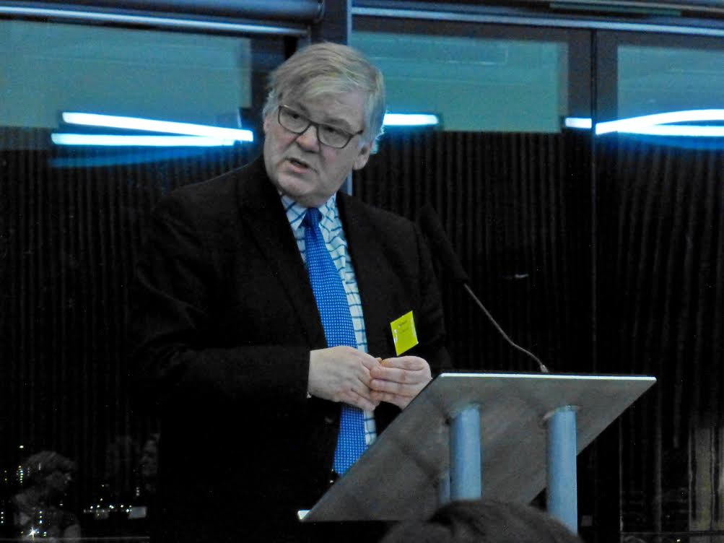
Another task for year one was to establish the board to help steer the project and build momentum (you can read more about the board in the May update). Since it first met in March 2014 the board has heard detailed plans from some of the main professions and agreed the priorities for the project’s focus.
BEPE board chair, Paul Morrell

The project has already started to have an impact. For example, following publication of their revised Professional Standards Framework the British Institute of Facilities Managers (BIFM) is now developing a Level 3 and Level 4 qualification in accessibility and inclusion management and will be creating resources for inclusion in BIFM Direct, the on-line learning and assessment solution for facilities managers. I wrote about this back in the June and September updates. By speaking at events and providing journal articles for professional publications, like this one in the RICS Building Control Journal word is starting to get out about the project. Do please help by promoting BEPE through your own professional journals and other appropriate media.
Gareth Tancred from BIFM at City Hall

As the end of the year has approached, our attention has started to shift towards the education sector. In November we held a workshop with a number of academics to gather views on what could help educators teach their students about inclusive design. The group told us that it was important that everyone had a basic shared awareness of inclusive design, regardless of how their academic and professional career then developed. The group said that common learning materials about inclusive design, which educators could weave into their courses, would be really helpful. This is an exciting area of work, and one that the project will increasingly focus on, so we’ll talk more about how we intend to progress it in future updates.

As we look back over the first year it’s clear that the project has got off to a good start, but we also know there’s lots more to do. Getting support from institutions is a great first step, but we’re well aware that the success of the project lies in converting these good intentions into lasting change. Our challenge, as we move into the second year of the project, is to continue to raise the profile of inclusive design and make it a talking point for the sector. We want to increase the level of demand for good inclusive design education, so it’s something built environment professionals know they need to and want to learn about.

We look forward to 2015 and hope you’ll continue to help us with this exciting project. If you have any comments or suggestions, or would like to get involved do get in touch via julie.fleck@dwp.gsi.gov.uk. You can also keep up to date with all things legacy-related via @2012govuk.

Happy Christmas and Best Wishes for 2015.

